Pokhara University

Level: Bachelor | Semester – Fall | Year : 2009
Programme: B.E. |  | Full Marks : 100
Course: Advanced Machine |  | Time : 3hrs.

Candidates are required to give their answers in their own words as far as practicable.
The figures in the margin indicate full marks.

Attempt all the questions.

1. | - Why single phase induction motor doesn't have any starting torque? Show that this motor can run either direction if once started.  - A 250 W, 230 V, 50 Hz capacitor start motor has following constants for the man and auxiliary winding Zm=(4.5+3.7j) and Za=(9.5+3.5J) . Determine the value of the starting capacitor to be inserted in auxiliary winding for maximum starting torque.  - Describe the construction and operation of capacitor start capacitor run induction motor. | 5  5  3
2. | - A six pole, 230 V, 60 Hz Y connected three phase induction motor has following Parameters referred to stator side on a per phase basis.  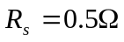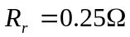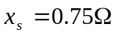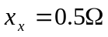  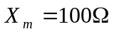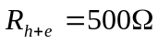  - A 20 hp, 400 V, 50 Hz three phase star connected induction motor has following test data  No load test 400 V 9A cos=0.2  Blocked Rotor Test 200 V 50 A cos=0.8  Draw circle diagram and estimate line current, power factor, slip and efficiency at full load. Assume stator and rotor copper losses are equal.  - Explain the power flow diagram of three phase induction motor. Derive the relation 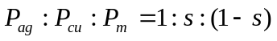  - Why is auto transformer starter preferred over stator resistance starter? | 5  7  8  5
3. | - A three phase, 8 pole, 750 rpm star connected alternator has 72 slots on the armature. Each slot has 12 conductor and winding is short chorded by two slots. Find the induced emf between lines, given the flux per pole is 0.06 web.  - Explain the two reaction theory of the salient pole synchronous machine. Draw the phasor diagram for a salient pole alternator supplying full load lagging power factor load. Also derive the load angle expression 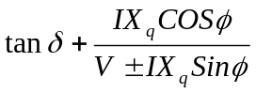 and power output per phase of the alternator is given by 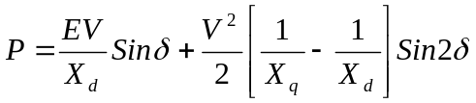.  - The following test result are obtained in 6600V alternator  A field current of 20 A is found necessary to circulate full load current on short circuit of the armature. Calculate regulation for 0.8 pf lagging full load by  - Synchronous Impedance Method  - Ampere Turn Method  - Why are winding short chorded in an alternator. | 5  3+7  7  5
  Open circuit Voltage (Volt) | 3100 | 4900 | 6600 | 7500 | 8300
  Field Current (A) | 16 | 25 | 37.5 | 50 | 70
4. | - Describe briefly the effect of varying excitation upon the armature current and power factor of three phase synchronous motor when input power to the motor is maintained constant.  - A 20 pole, 25 Kw, 660V, 50Hz, star connected synchronous motor is operating with its generated voltage exactly equall to the phase voltage applied to its armature.At loaded condition motor is retarded by  (degree mechanical) from its synchronous position. The synchronous reactance and resistance are 10 and 1 calculate  - armature current/phase  - Power developed  - Obtain the expression for the total synchronizing power 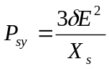  - what are the advantages of connecting alternators in parallel? What condition are required to be fulfilled for the successful parallel operation of three phase alternator? | 5  5  5  5
5. | - Describe about method of cooling of totally enclosed machines.  - Derive an expression for temperature gradient in conductor placed in slots.  - The total losses in 40 MVA transformers are 200 Kw. The oil for cooling is circulated by a pump. the oil after taking heat from the transformer tank goes to the radiators where it is cooled by circulated water. Calculate amount of oil which is raised by 20C in passing through tank. Also calculate the amount of water required for cooling oil in radiators. The rise in temperature of cooling water is 10C. Assume 20% of loss is dissipated by tank walls. | 5x3

